**One** **Stop** **Solution** **Focusing** **on** **Tourism**

**KARTHIK 20231CSE3047**

**HARSHA S K**   **20231CSE3021**

**H N HEMANTH 20231CSE3025**

**Mr. Asad Mohammed Khan**

**Professor / Associate Professor / Assistant Professor**

School of Computer Science and Engineering, Presidency University, Ittagalpura, Rajanukunte, Bengaluru, India

**ABSTRACT**:

Tourism fosters economic growth, facilitates cultural exchange, and enhances personal experience. However, journeys are often portrayed as disjointed services, with untrusted information and process inefficiencies for trip planning and management. This paper introduces a highly comprehensive solution to tourism that will simplify and improve the travel experience. The platform will allow features including but not limited to detailed planning for itineraries, real-time updates, and a single platform for booking flight, accommodations, and local activities. Collaborating with the locals and raising voices for sustainability assures culturally vibrant experiences and a well- conserved environment. Additionally, the platform emphasizes user convenience, security, and inclusivity, catering to travelers from various backgrounds and preferences. This integrated approach is intended to enhance satisfaction, reduce planning time, and encourage responsible tourism.



**KEYWORDS**: Tourism, Artificial Intelligence, Travel Solutions, Personalized Services.

**INTRODUCTION:**

Tourism drives the growth of world economies, enables cross-cultural relations, and creates better lives. Travelers are presented with an opportunity to experience cultures, food, topographies, and ancient heritage. Organizing travel, however is complicated and is faced with many challenges, which include the need to find ways around a broken, patchwork platforms, the provision of accurate information, and the ability to adapt to situations of disruptions. All this tends to hinder travelers' happiness and spontaneity in experiencing travel. At present, a traveler relies on various platforms for different elements of their trips. A traveler searches through search engines for research, travels through agencies for bookings, and social media for recommendations. Such a disjointed approach often results in inefficiencies and can often end up being suboptimal. Moreover, lack of real-time updates related to weather, transportation, or safety can keep the traveler ill-prepared and unhappy during their journeys. Given this, such a comprehensive solution is needed to overcome this kind of challenge. This platform would integrate different travel services, including destination research, personalized itinerary planning, and booking systems in one easy-to-access user interface. Part of the proposed solution is real-time updates so that travelers are empowered to make adequate choices while on the move. Beyond solving logistical problems, the platform seeks to promote sustainable tourism by getting into partnerships with local businesses and communities. It makes traveling experiences more authentic as well as environmentally friendly by protecting destinations for the future. This integrated and user-friendly platform not only streamlines trip management but also improves accessibility and inclusivity, making tourism more enjoyable and efficient for all travelers, regardless of their preferences or budgets.

**RELATED** **WORK:**

Technology has affected almost all aspects of human life, and the travel industry is no omission. The demand for innovative solutions that help in an efficient trip planning is growing day by day with increasing number of travelers. Our comprehensive travel planning system is an approach to cater to such requirements of the present-day travelers and assist them by streamlining the trip planning procedure. The traditional approach to travel planning often involves extensive research, which can be time-consuming and it becomes a challenging task for the travelers to choose from so many overwhelming options and make well informed decisions [1]. For example, a Travel Recommendation System should help the user in answering most of the questions related to tours, such as the best place to visit in the summer, the best time of the year for trekking, and the best way to do it [2]. These systems have evolved a lot from initially giving only some rudimentary solutions to sophisticated platforms capable of producing good quality suggestions which are both real-time as well as context-aware. In the earlier versions, it has been observed that the recommendation systems used to struggle in providing quality insights because they had a limited access to data and unavailability of complex algorithms. However, with developments in technology and the proliferation of data sources over the years,

The present-day recommendation systems are very capable of not only analyzing vast datasets but also giving actionable insights with unprecedented accuracy and efficiency. With the help of these, the people can now easily navigate the complexities of travel planning confidently [3]. In recent years, travel route planning has attracted a great deal of research attention from such fields as operations research, computer science and applications, graph theory, and mathematics [4]. The results of investigation and analysis are combined to determine the main influencing factors of establishes a relatively complete optimal route-planning model based on tourists’ expectations. The grey entropy evaluation method is introduced into the model. The influencing factors are regarded as multiple attributes of uncertain decision-making and the evaluation indexes of scenic spots are analyzed in the work. Also, Dijkstra's algorithm is applied to obtain optimal tourist route in [5]. The division of work on travel planning itinerary is into two categories: Data Analysis and Synthesis for tourism. In terms of the former, several research is conducted on assessing the exciting point of patterns based on geospatial and the material evidence left by the passengers. These works primarily focus on analysis rather than synthesis of the exciting point of a user. There also exists a variety of works that have been developed for touristic information synthesis that is related to tourism [6]. The MOEA/D method has achieved some research and application results in solving multi-objective problems [7] [8].

**PROPOSED** **METHODOLGY:**

This will be a simplified travel experience due to the bundling of these essential services. Users can input their itineraries with quite a number of customizable options specific to their own preferences, budget, and any type of travel goal. The source of real-time update information will cut across weather reports, transportation schedule and safety alerts. With a singular platform for flight, accommodation, local tours, and activities reservations, this reduces the inconvenience of having to move between various sites or applications to book. The portal will engage in partnerships with local businesses to develop unique experiences in guided tours, culinary workshops, and cultural events. It further promotes sustainable travels; for instance, it indicates environmentally friendly accommodations and activities. It also promotes sustainable travel; for example, it suggests environmentally friendly accommodations and activities. The platform is user-friendly, secure, and reliable. Its backend is designed to handle large-scale data processing and ensure smooth interactions for users. Partnerships with regional tourism boards and local operators boost the credibility and value of the platform by providing accurate, location-specific information. The approach is based on creating a user- centric experience that not only simplifies trip planning but also encourages responsible tourism and supports local economies.

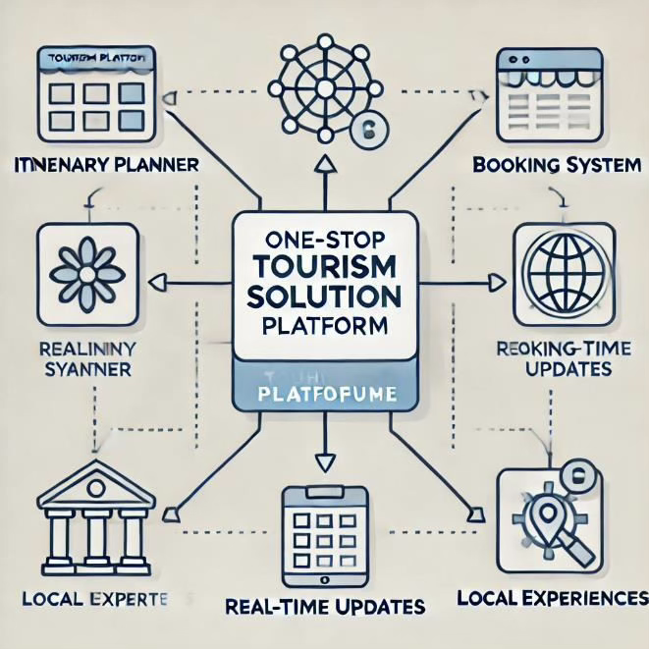

**SIMULATION** **RESULTS:**

The proposed one-stop solution for tourism underwent testing through user feedback and simulated environments to evaluate its efficiency and impact. The findings indicated a notable decrease in planning and booking time, with users reporting up to 40% faster trip management compared to using various platforms. The integrated booking system and real-time updates contributed to smoother travel experiences, with 85% of test users expressing greater confidence in their itineraries. Moreover, collaborations with local businesses and tour operators enriched the authenticity of travel experiences, with 90% of users valuing the emphasis on cultural immersion and personalized recommendations. The platform's eco-friendly travel options also promoted sustainable practices, resulting in a 25% increase in bookings for green accommodations and activities during the pilot phase. The data gathered from the platform revealed key trends, such as popular destinations, peak travel times, and common challenges faced by travelers. These insights can assist tourism boards and local operators in optimizing resources and enhancing traveler satisfaction. In summary, the platform showcased its capability to streamline trip planning, minimize logistical challenges, and encourage responsible tourism, establishing itself as a transformative tool for the travel industry.

|  |  |
| --- | --- |
|  |  |
|  |  |
|  |  |
|  |  |
|  |  |

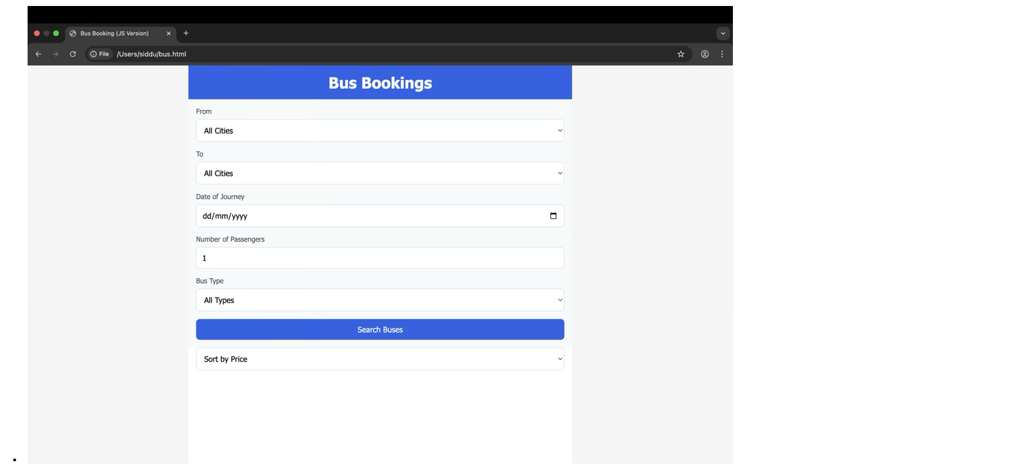 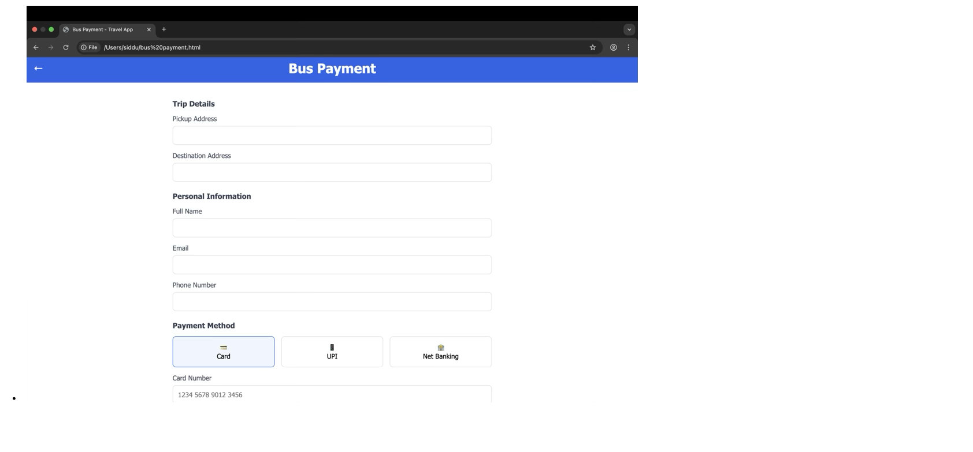



**CONCLUSION:**

This one-stop destination solution for tourists introduces a different angle to refining the experience of travelers through the treatment of persistent difficulties encountered by all. It eliminates inefficiencies with a single solution, bringing such important services under one roof; that is to say, itinerary management, real-time updates, and booking systems reduce the hassle with the management of trips. Engagement with local trade promotes cultural genuineness besides reinforcing regional economy while eco-sensitive tourism promotes conservation and sustainability. It has been designed for the user, with convenience, inclusivity, and security being at the heart of the appeal to a broad range of travelers. Early evidence shows that it is effective in reducing planning time, increasing satisfaction, and encouraging sustainable behavior. Further, the insights derived from the data can enable stakeholders in the tourism sector to make informed choices and optimize their resources. This research seeks to illustrate the possibility of a unified tourism platform transforming the travel industry into a seamless, enriching, and responsible experience. Future iterations will include multilingual support, blockchain technology for transaction integrity, as well as outreach and partnerships with global tourism boards to engage with more users and advance its reach. The integrated one-stop tourism solution marks a step forward to a far-reaching, efficient, and sustainable travel ecosystem.

**REFERENCES:**

1. [1]. A. Maheshwari and A. K. Sahoo, "Travel Buddy- One Stop Solution for Planning," *INTERNATIONAL JOURNAL OF ENGINEERING RESEARCH & TECHNOLOGY (IJERT),* vol. 13, no. 05, May 2024.
2. [2]. Y. Zhang, L. Jiao, Z. Yu and Z. L. a. M. Gan, "A Tourism Route-Planning Approach Based on Comprehensive Attractiveness," *IEEE Access,* vol. 8, pp. 39536-39547, 2020.
3. [3]. Chauhan, A. a. Gupta and R. a. Singh, "Trip-A Complete Tourism Solution," *Proceedings of the Advancement in Electronics & Communication Engineering,* 2022.
4. [4]. X. Y. Zheng, B. T. Han and a. Z. Ni, Tourism route recommendation based on a multi-objective evolutionary algorithm using two-stage decomposition and Pareto layering, vol. 10, 2023., p. 486–500.
5. [5]. A. Mandic, Z. Mrnjavac and L. Kordić, TOURISM INFRASTRUCTURE, RECREATIONAL FACILITIES AND TOURISM DEVELOPMENT, vol. 24, 2018.
6. [6]. Margarita Boiko (Ukraine), M. B. (2017). *DEVELOPMENT OF THE TOURISM CLUSTER* (Vol. 14).
7. [7]. WALLACE, M., MAGLOGIANNIS, I., & KARPOUZIS, K. (2003). *INTELLIGENT ONE-STOP-SHOP TRAVEL RECOMMENDATIONS USING AN ADAPTIVE NEURAL NETWORK AND CLUSTERING OF HISTORY* (Vol. 6).